**Objection to Planning Application ZB24/02455/HYB Based on Fire Risks**

**The Proposed Development Should Be Rejected on Grounds of Fire Risk, Toxic Risk and Failing to Meet Required Standards.**

The risk of fires and subsequent release of harmful chemicals on BESS sites is extraordinarily high. Global fire risk for 1GW of deployed capacity was 27% per annum in 2023. This is a 1GW site.

The risks of BESS sites are generally poorly understood because the technology is new with the majority of the construction taking place in the last two years. Commonly held assumptions about the risks are inaccurate.

The key hazards with BESS fires are:

* Fire.
* Explosion.
* Release of toxic gases over a wide area and subsequent harm to people and the environment.
* Release of harmful chemicals and substances in fire water run-off.

The exceptional size of the proposed development carries additional risks and hazards not seen in smaller sites.

These risks require a robust enforcement of fire and other associated safety standards.

The planned site fails to meet Local and National Safety Standards as well as contravening National and Local Policy.

Important standards this site fails to meet include:

1. Required 2nd road access for emergency services
2. Necessary and sufficient water supply to fight fires.
3. Insufficient physical division between containers and between ESS with in containers.

The request for a planning condition in section 9, criteria 9 of the verification compliance report for developer to decide their own water level standards should be firmly rejected.

There is precedence for planning to reject sites which fail to meet the standards above from numerous other failed planning applications. Planning should adopt the same policy here and reject the site for failing to meet these required standards.

**New Technology**

People often perceive battery fires as rare, but the reality is that the reason they seem uncommon is because battery sites themselves have been rare until recently. With the rapid expansion of Battery Energy Storage Systems (BESS) over the past year, the frequency of incidents is likely to increase as more of these facilities come online.

There has been a massive uptake in the number of grid scale battery storage systems in the last few years.

RethinkX in the article, “Where in the world is all the battery storage?”[1] observed:

*At the end of 2023, the world had approximately 56 GW / 200 GWh of grid-scale battery storage installed, up from just 3 GW 5 years ago.*

The rarity of fires until now doesn’t reflect the inherent safety of the technology, but rather the relatively small number of sites in operation. As we scale up, the occurrence of these incidents is bound to increase unless we seriously address the potential risks involved.

**Fire Risk Analysed by GW Capacity**

Fire risk is best assessed on the basis of fires per GW. Measuring per GW gives the best insight into of how many batteries are actually deployed and therefore risk.

Global figures are used as the only reliable basis for comparison due to the limited number of UK sites.

**Annual Fire Incidents per Global Capacity**

Comparing International Energy Agency data on battery storage capacity[2] to Electric Power Research Institute database of incidents of fires.[3]

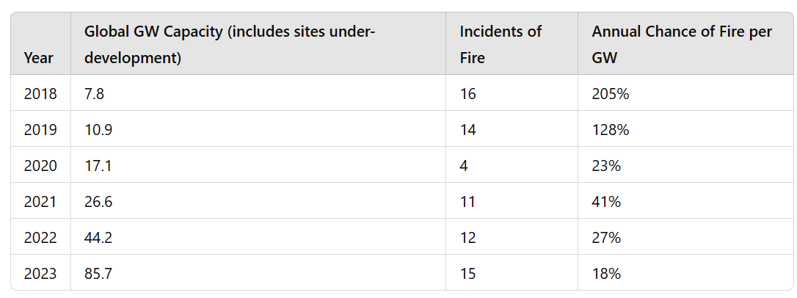

This historic data suggests a 1GW site like the one planned would have a 18% chance of having a fire every single year based on the 2023 figures.

The data from the International Energy Agency includes sites which are still being developed and so overestimates Global Capacity.

**Annual Fire Incidents per Deployed Global Capacity**

Comparing Incidents of fires in the Electric Power Institute database to deployed capacity as listed by Wood Mackenzie[4].

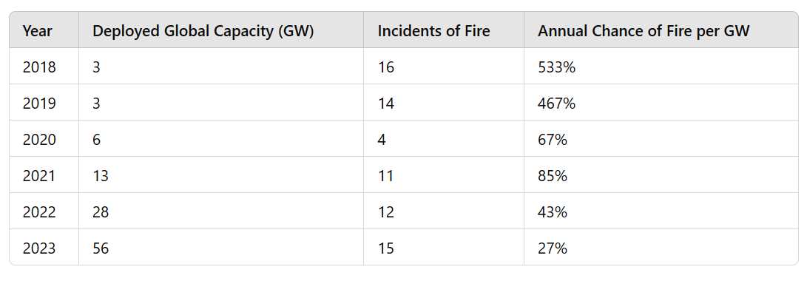

This shows that there is a 27% chance of a fire annually on a 1GW site such as the proposed development.

If both the Bellmoor and Mowbray sites were approved locally the risk of at least one fire a year in the local area would be 47%[5]

The actual fire risk is understated as the 22 Korean Fires during 2022-23 have been excluded

**Fire Risk Analysed by Site**

The risk of fire can also be looked at on a site-by-site basis. This is however problematic as small sites are a lot less risky than big sites.

The House of Commons Library recommends utilising the Electric Power Research Institute (EPRI) BESS failure incident database. This database is also used by the National Fire Chiefs Council. This database shows that there have been 89 fires.[6]

This figure does not include the recent South Africa, Table Mountain fire, the January 2025 Moss Landing fire or the 22 fires Korean Fires during 2022 and 2023.

The most reliable database of BESS sites globally is the USA Department of Global Energy Storage Database[7] shows 1040 operational BESS sites World Wide at the end of 2024.

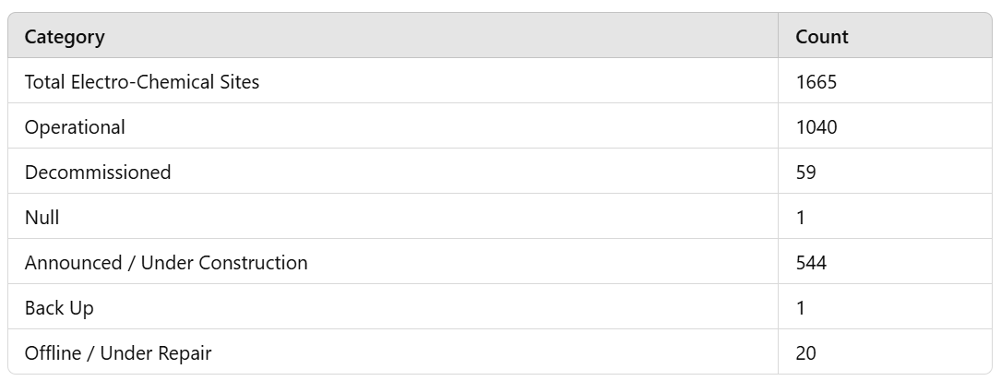

This database excludes very small battery sites and stringent verification standards mean some particularly very recent sites are excluded. This is however the best publicly available list and has been used in the US House of Representatives.

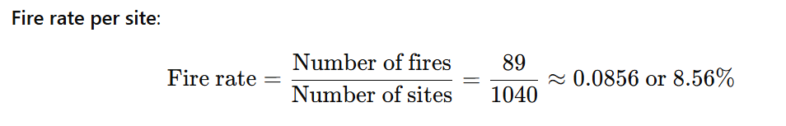

**Summary Fire Risks**

Based on the 2023 figures the annual risks of fire are:

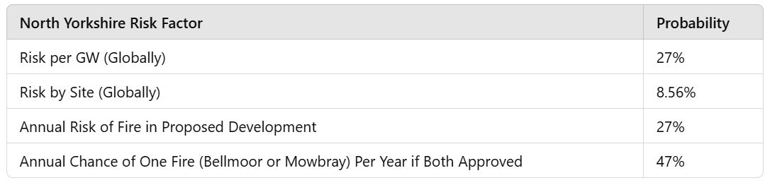

This level of fire risk is simply not acceptable on a single site.

**Larger Site Size Increases Risk**

Leading Experts Professors Dobson and Edwards from Oxford University observed:

*Lithium-ion batteries by their very nature are intrinsically fire—prone and are notoriously difficult to extinguish.*

*In terms of their large-scale in BESS, the more lithium, the larger the fire and explosion risks.*

Risks go up with site size. An individual battery risk may be low but put 10,000 of them together and only one needs to ignite to set them all on fire.

*During “thermal runaway” a single faulty cell can propagate to neighbouring cells. These are not “fires” at all, requiring no oxygen to propagate. They are uncontrollable except by extravagant water cooling.[8]*

The bigger the site the more interconnections and hence more risk, that a single issue can propagate, quickly creating a large impact. Simply put a site twice the size carries more than twice the risk. This site is too big to be safe.

Overly large sites place unreasonable demands on firefighting services and water supplies. On large sites fire fighters have to work to cool and prevent the spread to a greater number of containers dissipating their efforts and so increasing the chance the fire will get out of control. Fire fighters are also unfamiliar with the risks, and can themselves be injured or killed as they respond as happened in the Arizona BESS fire.

**Safer Is Not the Same Thing as Safe**

The claim that batteries are "safer" is often used as a reassurance, but it overlooks the fact that they were initially so dangerous that any improvement in safety seems significant by comparison.

Safer does not equate to truly safe; it merely reflects progress from a point of high danger.

**Hazards of BESS Fires**

The government commissioned the Frazer Nash Report[9] in BESS safety the hazards listed in the report were:

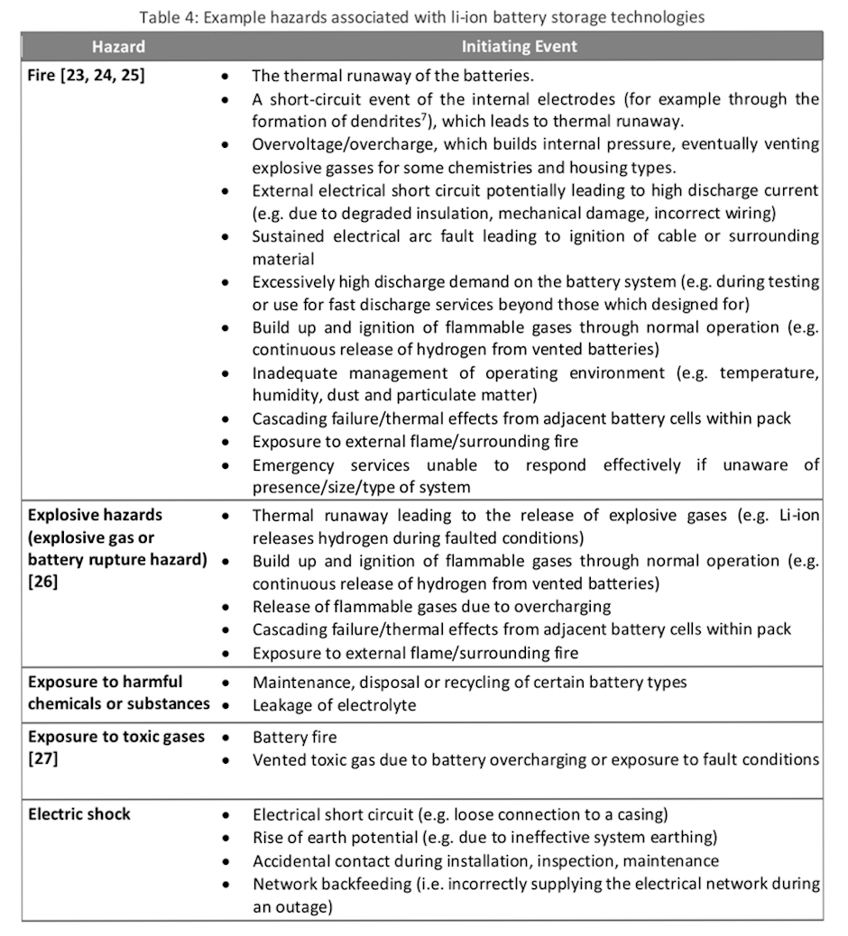

**Hazardous Substances**

Professors Dobson and Edwards state:

*Large- scale lithium-ion battery storage must surely be treated as a ‘Hazardous Substances or Materials Incident’*

The Faversham Society carried out a report written by Professor Wade Allison, Dr Fordham and Professor Sir David Melville, into the Liverpool fire they recorded the explosion on site, fire, a vapour cloud of hydrofluoric gas (fatal to humans) which then turned into an acid which could cut through concrete when exposed to water.

They considered the risk to be so extreme they asked the question “Grid-Scale Lithium-ion Batteries – the Next Grenfell?”[10]

Suffice it to say the impact of BESS fires are horrific and have resulted in a number of deaths around the world.

**Toxic Gases**

The plume report lists the following toxic gases as being released by a single cabinet

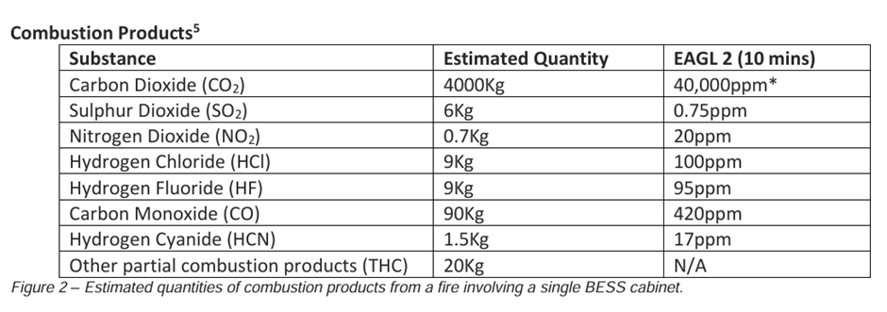

This list includes several “named substances” in HSC regulations due to their hazard.

Chemical plants containing these substances would be subject to Hazardous Substance Consent, COMAH (Control of Major Accident Hazards), and require an external Emergency Response Plan to be produced and tested with local authority, emergency services, health authorities. Similar large-scale modelling would be advisable in this instance due high level of risk involved.

There will be 8260 battery cabinets on site[11]. This means the potential emissions by a large-scale fire is as follows[12]:

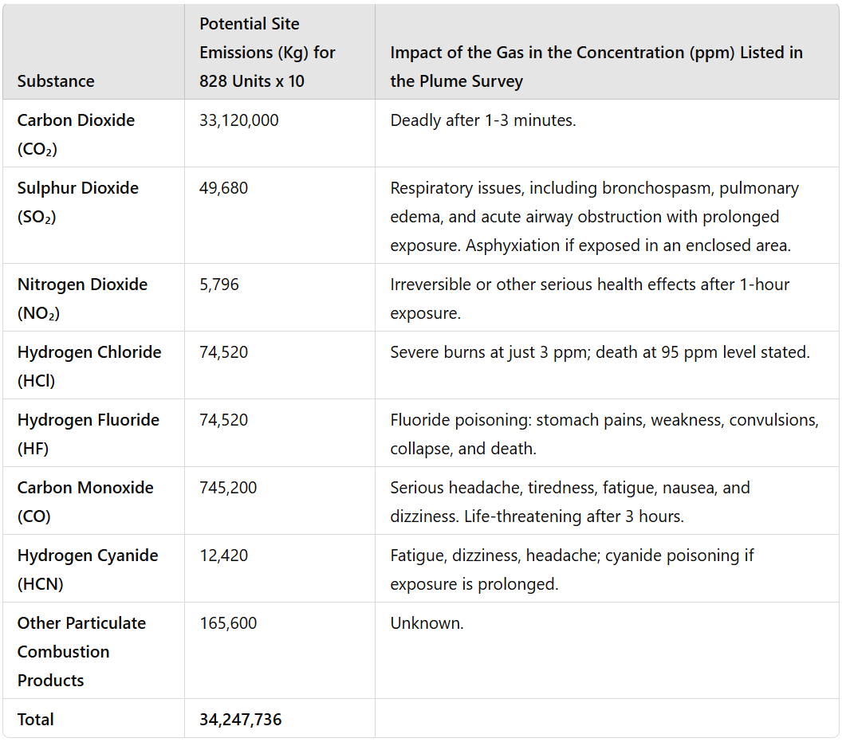

The Moss Landing Fire destroyed 40% of the facility. The Liverpool fire destroyed 25%. Gas release of a similar magnitude would be 13,699,095 kg or 8,561,934kg. The gas release in the plume study is calculated on just 10kgs of release.

**Duration of Fires**

BESS fires, are particularly dangerous due to the chemical nature of the lithium-ion batteries involved. These fires are not reliant on oxygen in the same way as traditional fires; instead, they are driven by intense, self-perpetuating chemical reactions within the batteries. This means that once ignited, the fire can be virtually impossible to put out, consequently these fires can last for days.

The Liverpool fire lasted 2 days. Victorian Big Battery Fire lasted more than 3 days. The recent Moss Landing Fire burnt for 5 days[13]. Otay Mesa BESS fire had fire services on site for 17 days[14]. A significant number of BESS fires have lasted multiple days.

The prolonged duration of BESS fires increases the likelihood of widespread damage, including prolonged road closures, evacuations, and long-term environmental consequences.

**The Site Lacks the Required 2nd Road Access for Fire Safety**

The application does not meet the advice set out in the North Yorkshire Fire and Rescue BESS advice to provide two separate access roads.

If you want firefighters to put out your fire, you need them to be able to get to it.

North Yorkshires Fire BESS Advice states:

*The site design should include a safe access route for fire appliances to manoeuvre within the site (including turning circles). An alternative access point and approach route should be provided and maintained to enable appliances to approach from an up-wind direction.[15]*

This advice from local fire services necessitates the creation of a second entrance which the site lacks.

National Fire Chiefs Council (NFCC) Grid Scale Battery Energy Storage System Guidance also set out that it is necessary to have two separate access points into the site. The NFCC policy states:

*In achieving adequate access for the FRS, firefighters should not have to enter the BESS site and drive through a vapour / gas cloud to reach the scene of operation. It is therefore preferable to have an alternative access point taking account of the likely wind direction.*

The term “preferable” can in law be taken to mean a priority choice this interpretation should be applied here. The necessity of approaching the site without passing through a gas or vapour cloud requires the 2nd entrance.

The Current NFCC Guidance makes this explicit:

*At least 2 separate access points to the site to account for opposite wind conditions/direction.[16]*

The representation of the criteria in section 5.53 of the Site Plan is misleading as it fails to contextualise the request for two access points.

The government Health and safety in grid scale electrical energy storage systems 3.4.2 Access routes, states:

***emergency scenarios****– consider how emergency responders, such as the Fire and Rescue Service or paramedics, can obtain access to and move around the site in the event of a fire or other emergency. This will likely necessitate at least two separate access routes onto the site in case one becomes obstructed or inaccessible.*

The governments guidance is clear that two sperate access routes are likely necessary. The size of this site should make the 2nd access route a requirement in this case.

Hazardous sites under COMAH regulations require a second access route. BESS sites are not specifically named under COMAH but the hazards are comparable and so comparable safety standards should be applied.

The purpose of two site entrances is to allow fire fighters to access the site without having to pass through a vapour or gas cloud to get to the fire. For firefighters to effectively extinguish a fire, they must be able to access the site of the fire.

The site fails to provide this required 2nd access point and this is sufficient reason for rejection by planning given the significant fire risks involved.

**Road Structure Around Site**

The existing road structure around the site means access to the site is along a single route. There are no roads to the North and the West of the site. Access from the east parallel road require passage along an inadequate single lane road which has the potential to become blocked in an emergency (perhaps by people exiting the area). The northern end of this single lane road has low bridge which would inhibit access by fire trucks.

The site fails to provide the Fire brigades recommended alternative approach route both in terms of local road network and because there is not a second entrance to the site itself.

**Other Access Issues**

NFCC guidance requires a turning circle and passing points on the roads within the site for emergency vehicles. Neither of these requirements have been met by the site plan.

Responses to BESS fires typically involve a large number of firefighters and firefighting trucks. The Beijing Bess fire required the response of 47 fire trucks from15 fire stations.[17] This was on a 25MWh site which is substantially smaller than the proposed development. Victoria Big Battery project saw approximately 150 firefighters and over 30 fire trucks respond to the fire.[18]

It would be prudent to carry out an assessment of locally available fire services and their response times to the development. It would be likely that a large-scale response of 15+ engines would be required.

The provision of hydrants is insufficient as it is likely the hydrants won’t be able to service the number of fire trucks required in a big fire. Ensuring sufficient access and hydrant supply for emergency vehicles is vital.

**The Plans Have Insufficient Water Supply**

NFCC policy states that a minimum of 180,000 litres[19] is required for a static water supply. North Yorkshires Fire Brigade sets a higher standard of 228,000 litres[20]. These figures should be considered as a baseline minimum.

The application does not meet the BS 9990 standards[21] for water supply which requires the supply of water to be increased with site size.

NFCC Policy states

*Fire hydrants and connections to any dry pipe systems that are required to be installed on the BESS site should installed in accordance with BS 9990 Non-automatic firefighting systems in buildings code of practice[22]*

BS 9990:2015 states

*Where more than one fire main is installed in a building, the potential need for additional water storage and/or pumping capacity should be taken into account.[23]*

The Current NFCC Guidance States:

*Water supplies will depend on the size of the installation.[24]*

There is a clear expectation that the available water supply should be increased in relation to the size of the site. It would be unreasonable to assume that a 5MW or 10MW site should have the same water supply as a 1000MW site.

Given the exceptional size of this site, the water supply should be significantly increased beyond the baseline requirements to ensure adequate firefighting capabilities and overall safety.

The 240,000 litres of provision out lined in the site map does not fit this requirement. The individual tank plan is insufficient to hold the required volume, so it can be assumed that the stated capacity refers to the total capacity, not the capacity of each individual tank.

**How much Water Does the Site Need?**

West Yorkshire Fire and Rescue Services concluded a 50MW site would need 5.5million litres of water to douse the fire. Stating in their response to Planning Application 23/03233/FU:

*Guidance suggests that lithium ion/lithium iron batteries should be doused with significant amounts of water, and ideally subject to full submersion of the batteries for a period of 24 hours. Taking a two ground monitor attack for 24 hours, would apply 5,472,000 litres of water (to confirm that is approx. 5.5 million litres).[25]*

This is more than 22 times the amount of water provided for this much larger development.

The fire report into 300MW Victorian Big Battery (VBB) in Moorabool, Victoria, Australia states that they required 900,000 litres of water to contain the fire.[26] This was on a site roughly 1/3 the size of the proposed development where they used the burn out approach.

The 6MW site in Drogenbos, near Brussels[27] required 1,400,000 litres of water during the 12-hour fire.[28] This is a tiny site compared to the proposed development.

8 million litres of water were used in the Otay Mesa BESS fire where fire services worked to control the fire for 17 days.[29] Other news reports suggest that the water deployed in relation to this fire was 15 -20 million gallons (57 million to 76 million litres)[30]

BESS fires on large scale sites routinely go on for several days. The current provision of water would last for just over two hours for one firefighting jet at high flow. There are no additional water sources in close proximity that could be called upon if needed. Given the high fire risk this is clearly inadequate.

The required water supply should reflect the size of the site. The BS 9990 standards of increasing supply in accordance with site size should apply. NFCC guidance to increase water supply with site size should also be applied. The site lacks sufficient water to tackle a large-scale fire and so should be rejected.

**NFPA 1142 – Water Requirements Not Fulfilled**

North Yorkshire Fire Services and the NFCC both state that safety standard NFPA 855 should be applied to Grid Energy Storage Systems.

NFPA 855 States in Section 4.9.4.2[31]

*Where no permanent adequate and reliable water supply exists for firefighting purposes the requirements of NFPA 1142 shall apply.*

The water calculation based on NFPA 1142 for a single container is as follows[32]:

This calculation has been based on a single container classified as OHC5 and CNC1. This is for an unoccupied building with the highest level of designed fire resistance. The figure produced is therefore very conservative.

(please note the calculation is feet and gallons)

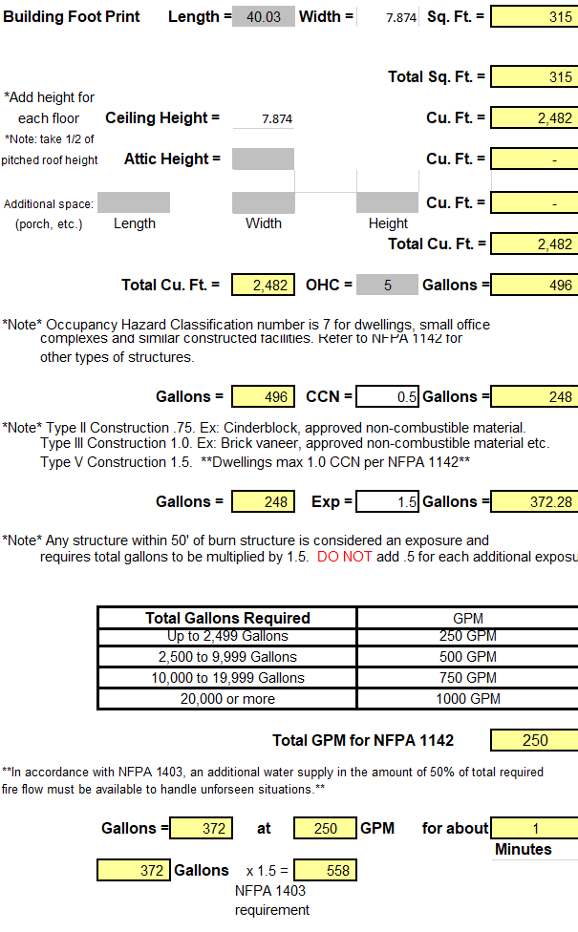

Therefore, for a single container 5,58 gallons of water are required or 2,113 litres. The 828 containers on site requiring a total of 1,752,576 litres of water to meet NFPA minimum standards. This calculation ignores the requirements of the other structures on site. The NFPA also states that the stored water capacity should increase depending on local conditions and conditions on the site. The potential long duration of the fire and its high intensity would both be factors which would increase the water provision beyond this level under NFPA standards.

The provision on the site is woefully inadequate compared to the NFPA standards, planning permission should therefore be rejected.

**Additional Water Requirements – Fire Suppression Systems.**

The Fire Suppression System needs additional water supply for the water supply pipeline. The verification compliance report states each BYD MC Cube ESS contains a “water supply pipeline”.

There must be water supply in excess of the requirements for supplying firefighting jets to supply this fire suppression system. Failing to do this could lead the water firefighters require for jets, being automatically taken away when the 8280 cabinets attempt to self-cool in the event of a fire.

NFCC advice is to utilise a water-based water misting system over a gas system. The reason stated is that gas systems can only be deployed once but water-based systems can be deployed multiple times to cool units. There is an expectation that water supply should be able to supply multiple deployments of the system.

**Requested Planning Condition for Developer to Decide Water Levels After Planning Should Be Rejected.**

Council planning should decide the required level of water on site not the developer. The council’s duty of care requires them to decide this issue, not the developer.

The determination of required water supplies and the emergency plans are distinct elements in NFCC guidance and they should not be conflated.

Natpower's request to determine the required water on site as part of the "Emergency Response Plan" or "Integrated Fire Risk Management Plan" is wholly inappropriate. This approach leaves the decision to the applicant without clear, enforceable standards, undermining the safety and compliance of the development once constructed.

NFCC requirements to liaise at the earliest possibility have not been met. There is a track record of not engaging in proper liaison. Freedom of information requests to the local Fire Authority[33] and the Police Fire and Crime Commissioner[34] show that Natpower have failed to liaised with the local fire services prior to submitting their planning application, in breach of NFCC advice.

Given this track record, there is no reasonable expectation that they will adhere to best practices for communication and coordination in the future. Natpowers track record of only providing minimal water supply in other development applications indicates they would likely do the same in this instance.

Section 3.5 of the Government Guidance - Health and safety in grid scale electrical energy storage systems makes it clear that emergency response plans should be considered at each stage, this includes planning. Allowing plans to be developed at a later date and allowing key aspects of planning would be a failure to follow guidance.

The request for the planning condition in section 9, criteria 9 for developer to decide their own water level standards should be firmly rejected. The council planning must remain the decision maker on safety requirements not the developer. The 1,752,576 litres required under NFPA should be a minimum requirement for the site.

The development has not planned for sufficient water supply and therefore it should be rejected.

**Fire Will Spread If Not Controlled – Required Spacing Between Units**

The Frazer Nash Report, Health and safety in grid scale electrical energy storage systems makes it clear that there is a risk of a cascading effect as one container ignites another.[35]

The Plume Report assumption that “Fire should be limited to a single battery module (rack) within a cabinet”, is inaccurate. If a burn out strategy is employed as the report suggests the whole container containing 10 cabinets will burn as a minimum.

Firefighters are advised against opening the container doors (NFPA 855 Task Group) in the event of fire. Opening the door leads to a risk of explosion “This is what happened at the McMicken ESS in Surprise, Arizona in 2019, resulting in four firefighters being injured”.[36] If this advice is followed a single rack fire would inevitably spread to other racks and cabinets.

The site has requested a reduced separation distance between containers of just 3m. This is based on compliance with the UL9540A. changing the applied NFPA 855 Standards.

UL9540A standards require an installation level test to be applied. The site can not apply this test as it has not been constructed. It therefore can not accurately claim it meets UL9540A standards, only state that it hopes to do so. The NFPA 855 Standards do not allow the reduced separation distance between units unless the standard has been met.

Current NFCC guidance states that they want to see a 6m gap between containers.[37] The development does not meet this standard. NFCC standards should take precedence and be upheld. The high risk of fire spreading from container to container means the conservative approach should be taken.

**Site Does Not Meet NFPA Standards On Separation of Individual ESS Units Within Containers**

NPFA 855 states:

9.4.2 Size and Separation

9.4.2.1 ESS shall be comprised of groups with a maximum storage capacity of 50kWh each.

9.4.2.2 Each group shall be spaced a minimum of 3ft (0.91m) from other groups and from walls in the storage rooms or area.[38]

The individual ESS units are the individual battery cabinets contained within the container.

The MC battery cube proposed in the plume report is 2,438 mm wide. The container plan submitted is 12.2m long and 2.4m wide.[39] The designed containers do not have the required 0.91m of separation of the battery cabinets from the container walls or each other on each side. The proposed development does not adhere to NFPA standards.

It is also not physically possible to fit in 10 battery cabinets (as stated in the plume report) in the containers well adhering to NFPA standards on separation between ESS units. The sites plan therefore breaches NFPA safety standards and should be rejected.

Planning should insist on adequate separation between units to slow the spread of the fire to allow Fire Services time to attend the scene and so contain the scale of the fire.

**Site Does Not Meet NFPA Standards On Separation Between Containers**

Yarm is the nearest fire station is 11km away via the road route. An approximate response time of approximately 9 minutes could be expected but this could be increased by traffic or other obstacles causing delays. This timescale would be sufficient for a BESS fire to go out of control. The thermal runway of battery cells triggers a chain reaction where neighbouring cells overheat and ignite. Explosions are common and can cause the fire to rapidly spread to neighbouring containers.

The risk of rapid escalation of the fire means that measures which would delay the spread of the fire are vital. A key component of delaying the spread of fire is the separation distance between individual racks/battery units with containers and the separation of containers from each other.

For separation between containers NFCC guidance states:

A standard minimum spacing between units of 6 metres is suggested[40]

This standard has not been met in the proposed plan.

The scale of the site overrides any other design considerations as the scale of the site necessitates that the highest standards of fire safety are applied throughout. Reduction to a lower separation level between units should not be permitted due to the inherent risks of the development which would be the largest battery site in the world if built today.

Clustering of units together is an aggravating risk factor as fire can spread between units. Fire brigades around the world such as New South Wales Fire and Rescue Service apply regulations to prevent clustering. NSW policy stating:

*The BESS units must be segregated into clusters, with each cluster not exceeding 50 meters in length on any side.[41]*

The adoption of measures against the clustering of containers would be desirable to prevent large scale fires.

**Detached Building Exemption Does Not Apply - Implement Full Building Regulations To Battery Containers**

The exemption under section 2 for detached building should not apply to the battery storage containers for this site. Instead, the full planning regulations should apply.

Under Schedule 2 of the Building Regulation 2010, detached buildings are exempt from the building regulations if people do not normally enter them or they only enter intermittently to inspect or maintain plants or machinery.[42]

"Intermittently" refers to events that occur at irregular intervals, stopping and starting. In UK law, it often describes sentences or orders served in separate periods. Although there is no precise judicial definition, it typically refers to events that occur at irregular intervals. Both the Cambridge Dictionary and Oxford Learner's define it as something that happens intermittently, without regularity. This concept is widely understood in both legal and everyday contexts.

During the public consultation the developers made it clear to the public that the battery units would be inspected twice weekly. This is by definition not intermittent due to its regular recurring nature. The exemption under section 2 of the Building Regulations Act 2010 cannot therefore apply and full requirements of the act must therefore apply instead.

**Explosion Risk**

It is typical for there to be an explosion at BESS sites early on during the fire. The best-case scenario is for this explosion to happen before emergency services arrive on scene as this avoids injury and loss of life. This explosion will often lead to the rapid spread of the fire to other units.

New Works Safety Management Plan notes in relation to Lithium Iron Batteries

LFP cells do have higher thermal runaway threshold temperatures, *however*, the very fact that LFP cells fail less aggressively allows more and more combustible aerosols, flammable gases etc to build up before ignition occurs, leading to a Vapour Cloud Explosion (VCE), therefore the risk of VCE is higher.[43]

Going on to say:

LFP BESS do fail and when they do, can be catastrophic and fatal.

The fires can be invisible to the naked eye at the point of combustion due to the high levels of hydrogen being burnt. This creates additional detection and responder risks.

**Major Accident Hazard Pipeline**

The pipeline is located in close proximity to the site. The pipeline transports Ethylene. There is the potential for cascading impact where the fire on one site leads to the spread of fire to the Hazard Pipeline. It should be noted that SABICs decision not to object to the site is based on predetermined criteria. A key part of this criteria is the hazardous nature of the site and BESS sites being new in nature are as yet not appropriately categorised.

Explosions can and do cause ground disturbance which could potentially cause pipeline failure.

**Plume Study is Not Fit for Purpose - Grossly Underestimating Risks**

The plume study is not fit for purpose and does not provide an adequate basis to determine the extent of the spread of gases.

The key issues with the report are:

**Magnitude**: The report assumes a release of 10 kg. The BESS site has the potential to produce approximately 34million kg[44] of emissions from batteries alone.

**Based on Single Rack Fire**. Cabinets contain multiple racks. The plume report states that 10 cabinets are installed in each container. The whole container could be expected to burn in the event of a fire, and this is supported by incidents which have occurred. The timescale of release should also be taken into account.

**Hydrogen Floride is Only Gas Analysed:** The removal of other gases from the study of the fire artificially reduces scale of the gas plume produced. It is incorrectly assumed the Floride ion will largely remain a salt rather than turning into a gas when exposed to the fire. All gases should be modelled to ensure a complete understanding of potential consequence.

**Inappropriate Point of Comparison**: Car fire and car workshop fires do not provide a valid point of comparison. The report even states that the gas produced by one of these fires will be greater than a BESS site fire. This is delusional. A fire on a major industrial site will be much bigger. There is plenty of data from industrial releases of gas which would provide a more relevant point of comparison.

**Wind Levels Underestimated:**  The report uses averages wind figures for the month. This does account for the wide variation in weather actually experienced. The report utilises “outliers” in the wind calculation. Simply put the lowest figures were selected, reducing the apparent impact of wind. The application of COMAH regulations on wind calculations would be appropriate.

**Underestimation of Forces Driving Gasses**. The report unrealistically determines the smoke will not rise over 2m in height. The upward convection currents will be significantly higher, due to the fire burning with an intensity comparable to rocket fuel. The current plume study is unreliable and a new study should be carried out by a qualified person to give a reliable understanding of the consequences of gas release.

**Fires Impact a Wide Area**

West Yorkshire Fire Brigade wrote in response to a recent BESS application.

*The risks of vapour cloud, thermal runaway and explosion are unfortunately very real and are becoming more common as we see an increase in the number of BESS installations rise.[45]*

The impact of the fires is not restricted to the site of the fire because the toxic smoke travels.

The Moss Landing January 2025 Fire had an evacuation zone spanned approximately 12 square miles, causing 1500 people to be evacuated. The Victorian Big Battery in Moorabool, Australia resulted in a lockdown of residents in a 9km radius due to the risks posed by toxic fumes and smoke, highlighting the severe disruption.

Local wildlife and livestock will also be impacted by the vapour cloud and can not be evacuated.

It realistic to consider that a fire in the proposed site may lead to the closure of the vital road link the A19 for a period of several days. There is also a risk to local aviation.

The Major Incident Investigation Board concluded costs from the vapour cloud released in the Buncefield Oil fire which closed the M1 in 2004 included[46]:

Aviation Costs £245 million

Compensation Claims (business & individuals) £675 million

Competent Authority and Govt Interventions £15 million

Environmental impact to water supplies £2 million

Emergency response £7 million

Fire represents a high economic cost to the local community and to North Yorkshire Council. The Major Incident Investigation Board set out in the Brucefield report a formula for determining annual costs to a local area of a development, by dividing the cost of an incident by the probability of its occurrence. The proposed development can therefore be considered to cost the local area £255 million annually given the high probability of fire and comparable costs.

The governments analysis of the vapour clouds impact showed there was a significant rise in unemployment in the local area as business relocated out of the area or closed. This an economic harm and it ensures the proposed site is not economically sustainable. It is the wealthy who can afford to leave an area while the poorer members of society cannot. This creates social inequality which is against the requirements for a social sustainability in planning.

Plume Report Underestimates Size and Height of Gas Cloud

A BESS fire looks Like this:

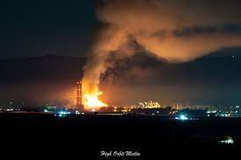

This is the Moss Landing Fire. The 500m stacks (from a previous, now closed site) in the image give some idea of the height of the fire. The flames visually appear to reach at least 300m in height, maybe 400m in height. The smoke reaches more than 3 times the height of the towers at over 1500m. The plume report estimates the smoke will reach “a height of approximately 2m”. It is a gross underestimate.

The plume report notes “The presence of fire will create upward convection currents based on the intensity of the fire.” This means high intensity fires such as those experienced on BESS sites will drive the smoke significantly greater distances than the Plume Report suggests.

Anyone who has set a fire in their garden knows the smoke goes more than two metres in the air. An unrealistic set of assumptions have been chosen for the Plume Report making the risk of fumes appear artificially low. Such judgements prejudice the whole of the fire reports efficacy.

Claims in the fire report suggesting that the fire would be similar to a car fire or a bedroom fire are equally unfounded. The fact that 1,500 residents around Moss Landing were evacuated shows that BESS fires bear no resemblance to such typical scenarios.

The plume report greatly underestimates the extent and reach of the fumes from a BESS fire.

The Hawkschurch Battery Storage Appeal (against rejection of the development) looked at:

*whether there is sufficient information on the health and safety measures proposed and the extent to which there would be significant risk to local residents and the environment.[47]*

The inadequacies and bias of the fire reports mean that these requirements have not been fulfilled for this development.

**Environmental Damage from Fire Water Run-Off**

Government Guidance: Health and safety in grid scale electrical energy storage systems, acknowledges contaminated run off as concern for BESS sites.

West Yorkshire Fire Service noted in response to BESS planning application:

Due to the large amount of water required, the Environment Agency will need to be consulted, as the water run-off will be contaminated.

Chemical contamination of the local areas soil, groundwater, watercourse can occur. Runoff water used for firefighting could carry toxic chemicals, heavy metals, and electrolyte compounds from damaged batteries into nearby water bodies.

As noted in Section 3.33 of Hambleton District Publication Local Plan Habitats Regulations Assessment:

*At high levels, toxic chemicals and metals can result in immediate death of aquatic life, and can have detrimental effects even at lower levels, including increased vulnerability to disease and changes in wildlife behaviour.[48]*

There is precedent for rejecting BESS sites on the basis of water run off risks. In the Hawkschurch Battery Storage case:

*HAG called expert witnesses who presented evidence that there was a serious risk of contaminated fire water run-off reaching the village water supply, resulting in the appeal being dismissed.[49]*

The local area has 4 houses dependant on private (off mains) water supply and their drinking water would likely be impacted by the runoff from a fire.

The Environmental Agency concluded pollutants were present in the water system 2km away from the site of the Buncefield firefighting water runoff. This caused the permeant closure of local water bore holes and cost 2.1million in clean-up costs.[50]

**Precedent for Rejecting BESS Based on Fire Risk**

The decision letter in the Hawkschurch Battery Storage case read:

*this particular proposal fall[s] short of the national recommended standard without safety being demonstrated, with the risk compounded by only one access and unclear measures on containment of firewater and the potential to contaminate the aquifer, as well as the likely need for widespread importation of firewater.[51]*

Murton Way BESS, Yorkshire proposal was rejected in December 2024 due to the lack of a 2nd road access.[52] The Cleve Hill BESS, Kent was rejected due to inadequate water supplies. There are numerous other examples of similar rejections based on fire risk[53]. The same standards should be applied in this case especially when the scale of the development is accounted for.

**Security Concerns**

Security on the site is inadequate. Government guidance states that security provisions should be considered on BESS sites, this has been done to only the most basic degree on this site. The site is unmanned and dependant on security cameras. It would be impossible to prevent harm to the site due to the offsite response time, even if a threat was immediately noticed.

The risks of terrorism or vandalism triggering a large-scale event is very real. It is typical for High Hazzard COMAH sites to be audited by counter terrorism to ensure security is sufficient to prevent terrorism and vandalism. The risk on this development mean it would be prudent to exercise the same level of caution.

It may be considered by planning that on-site security is inadequate given the potential risks from a deliberate act.

**National and Local Policy Conflicts**

The proposed site conflicts with a number of local and national policies. The site also breaches a number of relevant safety rules and guidelines.

**Local Plan Conflicts**

* **Policy RM1:** Run off from fires will be contaminated and so present an adverse impact on quality of water
* **6.16:** Risks of air pollution, water quality and contamination.
* **6.35:** The storage of hazardous materials applies due to the lithium in the batteries. The policy requires there will be no adverse effect on safety near a notifiable installation and there will be no increase in the number of people at risk in the vicinity.
* **6.37:** Protecting watercourses from air pollution and contamination.
* **6.45:** Site is surrounded by farmland and so water runoff from fires has the potential to impact eco-system services. Food production and water supplies will be impacted.
* **7.17:** Inadequate provision of emergency services access. Only one access road provided.
* **7.25:** Site does not facilitate two access roads for fire services which are appropriate to the nature of the site.
* **8.33:** The site risks contamination of the ground.
* **8.39:** Fire run off risk contamination of groundwater supplies endangering human consumption.
* **8.40:** Water run-off from fire control is an intrinsic risk of BESS site. Policy states “intrinsic hazard to groundwater and are unlikely to be acceptable. The hazard may result from a combination of the activity type, its duration and the potential for failure of controls.” The risk of fire is a failure control.
* **8.5:** A significant impact on water quality due to surface and wastewater discharges and the storage and processing of potentially contaminated materials. Water run-off from fire will pollute the local environment and endanger human water supplies in local homes not connected to mains water.
* **S1:** Sustainable Development Principles (f) – risks to water and air quality.
* **E1 Design:** The site has an unacceptable impact on the amenities or safety of future occupiers, for users and occupiers of neighbouring land and buildings, as well as the wider area or creating environmental and safety concerns.
* **E2 Amenity (d):** The adverse impacts from the following risks cannot be made acceptable, air pollution, contamination, dust, obtrusive light, overheating; and water pollution.
* **E2 Amenity (f):** There would be a noticeable safety effect and the number of people put at risk would increase.
* **RM4 Air Quality 8.23:** Fire creates unacceptable risk of air and water pollution.

**National Planning Policy Frame Work**

* **117:** Access for emergency vehicles is compromised due to the lack of 2nd road access.
* **187:** The local community will be at risk of air, soil and water pollution due to fire hazards.
* **196:** Insufficient attention has been given to the risks of land contamination from water runoff and the measures required to prevent it.
* **197:** Responsibility for avoiding contamination issues rests with the developer/land owner. In this case adopting smaller developments across multiple sites would be desirable to mitigate the risks.

**North Yorkshire Fire Service Policies Not Met.**

* *“Including redundancy in the design to provide multiple layers of protection.” -* Reducing separation distances between units runs against the redundancy design principle.
* *“Developing an emergency response plan with NYFRS to minimise the impact of an incident during construction, operation and decommissioning of the facility.”*  - No plan has been developed. This should be available to planning.
* *“Ensuring the BESS is located with due considerations of impact on communities, sites and infrastructure.”* - The site is out of character with the landscape and existing infrastructure.
* *“Prevailing wind directions should be factored into the location of the BESS to minimise the impact of a fire involving lithium-ion batteries due to the toxic fumes produced.”* - Approach to the site is from the prevailing wind direction and no alternative access provided. Increased weather events should also be considered here.
* *“Environmental impact should include the prevention of ground contamination, water course pollution, and the release of toxic gases.”* – No plan or means to control water runoff, which in this case would endanger human water supply and impact food production land.

**National Fire Chiefs Council Policy – Guidance Conflicts**

* *“Adequate separation between containers.”* – Separation is inadequate.
* *“Ensure that sufficient water is available for manual firefighting.”* - The water supply is insufficient for the size of the site.
* *“The site design should include a safe access route for fire appliances to manoeuvre within the site (including turning circles). An alternative access point and approach route should be provided and maintained to enable appliances to approach from an up-wind direction.”* - Only one access road has been provided.
* *“The site design should include a safe access route for fire appliances to manoeuvre within the site (including turning circles). An alternative access point and approach route should be provided and maintained to enable appliances to approach from an up-wind direction.”* - No turning circle provided. No passing points for fire trucks on internal roads. Local road network does not allow approach from an up-wind direction.
* *“Safe access for emergency responders in and around the facility, including to energy storage infrastructure and firefighting infrastructure.”* - The site lacks a 2nd road access and manoeuvrability around the site is limited by the lack of turning circles and passing points.
* *“Effective identification and management of hazards and risks specific to the siting, infrastructure, layout, and operations at the facility.”* - The site has not developed the required evacuation or hazards plans. The extreme downplaying of risks in the plume report suggest the risk have not been fully understood or accounted for.
* “A standard minimum spacing between units of 6 metres is suggested”– The high risks associated with the site means that this should be treated as a minimum standard. The proposed plans fall below this standard.
* *“Provision of adequate water supply and firefighting infrastructure to allow safe and effective emergency response.”* - Water Supply is inadequate to the sites needs.
* NFCC in its response to guidance questions set out that developers should communicate with local fire services at the earliest opportunity. Freedom of information requests prove this has not been done.

**National Fire Chiefs Council Policy Conflicts**

* *“There must be an appropriately sized water supply for the FRS to use in a location that promotes expediency of supplying water.”* - The water supply has not been scaled up adequately for the size of the site.
* *“Any calculations for sufficient water supply for an appropriate suppression system will need to be completed by a competent person considering the appropriate risk and duration of any fire.”* - The water requirements for the suppression system should have been calculated separately from the main water supply provided, this has not been done.
* *“The likely path of any vented gasses or materials should be identified in emergency response plans to reduce the risk to responders. “* - No emergency response plan has been produced and the plume reports estimates are so low as to be invalid.
* *“In achieving adequate access for the FRS, firefighters should not have to enter the BESS site and drive through a vapour / gas cloud to reach the scene of operation. It is therefore preferable to have an alternative access point taking account of the likely wind direction.”* - There is no second access road and the sites size and local road network make this a necessity in this instance.
* *“Fire Hydrants and connections to any dry pipe systems that are required to be installed on the BESS site should installed in accordance with BS 9990 (Non-automatic firefighting systems in buildings - Code of Practice)”* - The BS 9990 standard requires water supply to be scaled with site size and this has not been done.
* *“Adequate separation between the BESS enclosures to ensure that the radiant heat from a thermal event in one BESS will not trigger a secondary event.”* - The enclosures are too close together and do not meet this standard
* *“There must be enough water available for firefighting to take place and to manage a reasonable worst-case scenario.”* – A reasonable worst case scenario would be 40% of the battery units on fire as happened on Moss Landing. Or 25% destruction as seen in the Liverpool Fire. The water supply provided would not cope with either of these scenarios.
* *“Suitable environmental protection measures should be provided. This should include systems for containing and managing water runoff. System capability / capacity should be based on anticipated water application rates, including the impact of water based fixed suppression systems.”* - The plans provided are inadequate and do not assess this risk properly.

**NFPA 855 Conflicts**

* **9.4.2**: Inadequate separation of ESS inside the containers. The units are individually certified not group certified.

Distance between containers is not the required level.

**NFPA 1142 Conflicts**

* NFPA 1142 applies due to the provision of NFPA 855 section 4.9.4.2. The minimum water availability requirements are not met.

**Water Framework Directive**

* There is a legal obligation to prevent water contamination of the type which would be experienced in the event of a BESS fire creating polluted water runoff.

**Conflicts with Government Guidance - Health and safety in grid scale electrical energy storage systems**

**3.1.1 BESS risk assessment**

* *“The assessment should consider the total energy stored in the BESS and the population which may be affected by particular hazards.”* - Inadequate consideration of the scale of the site has been carried out. The site if built today would be the largest in the world. The risks escalate with site size. Additional safety measures are required for very large sites but the developers plans are minimum standards or below.
* *“Planning applications and decisions should always be taken with a complete assessment of risks and impacts, both of the facility and the surrounding environment.”* - The plume report is not fit for purpose as it selectively analyses the risks in gas type and is based on an unrealistically low release of gas of just 10kgs.
* *“There should be a full consideration of risks including, but not limited to, accidental or intentional damage and natural phenomena and security. Note that risk assessments should be bidirectional – i.e., include both risks to the project and from the project.”* - Consideration of natural phenomena and security risks has not taken place. The site is vulnerable in terms of security as large scale fires affecting infrastructure can easily be caused due to the inherent nature of the site. There is no adequate analysis of run-off risk provided. Run-off risks (from water extinguishing a fire) are specifically mentioned in the lists of risks but are not addressed. The risk assessments carried lack a bi-directional aspect.
* *“The planning process should assess the following risks and describe how the credible worst case has been mitigated.”*  - The worst-case scenario in the plume report is not credible. It is entirely realistic to consider that more than one container may catch fire. This has not been done.

**3.1.2 Risk assessment and reduction**

* Risks are to be managed via *“inherently safe design”.* The site is not inherently safe. Design should apply the highest standards to aspects such as unit separation not below minimal or minimal levels.

**3.2.1.2 Battery system capabilities, architecture and control**

* *“Battery systems are developed in a modular fashion, where individual battery cells are combined to create modules, modules are combined within racks, and these can then be combined to make fully containerised battery systems (usually with in-built control, protection and safety functions). Grid scale applications consist of multiple containers”* - The modular nature of the design could have been used to mitigate risk by reducing the concentration of units either on site or across multiple sites, this has not been done.

**3.4.2 Access routes**

* *“emergency scenarios – consider how emergency responders, such as the Fire and Rescue Service or paramedics, can obtain access to and move around the site in the event of a fire or other emergency. This will likely necessitate at least two separate access routes onto the site in case one becomes obstructed or inaccessible.”* - Only one access route has been provided, given the sites size this is inadequate and a gross oversight to the health and safety of first responders.

**3.5 Emergency planning**

* *“Emergency response arrangements and preparedness plans should be developed as early as possible in the system lifecycle and be considered at each stage.“* - The emergency response plans have not yet been produced. They therefore cannot be considered by planning as is required.

**The Fire Safety Order**

* The site should be considered to contain “dangerous substances”. The fire safety order should be applied and this should be a condition of planning.

**Conflicts with the House of Commons Briefing - Battery Energy Storage Systems**

* *“the design of the BESS facilities can also help ensure their safety. In BESS facilities, battery packs can be spaced out and have insulation between the cells to prevent the spread of fire.”* - The batteries are insufficiently spaced inside the container units and the containers are too close together. Sufficient advantage of design to mitigate risk has not been taken.

**Schedule 1 of the Building Regulations 2010.**

* Part B requires buildings to be designed and constructed to limit the spread of fire within and between buildings, to have systems that give early warning of fire, and to allow fire and rescue services to access a building and assist them in fighting a fire.
* The containers are not eligible for the exemption under schedule 2 as a result of the stated regular weekly inspections. This does not fit the classification of intermittent. The full building regulations therefore apply to the container units.

**Conclusion**

The development contravenes a significant number of local and national policies in relation to fire and its effects.

The risk of fire on a site this is very high. This is new technology. The rarity of BESS fires up to now is due to the rarity of BESS sites, not a lack of risk. Risks compound with site size, low risks for battery cells become substantial when you put approximately 4million cells on one site. Only one needs to fail to start a major fire.

Key reasons the development should be rejected.

1. Lacks 2nd road access for fire services
2. Lacks adequate Water Supply.
3. Lacks required separation between individual ESS units in containers.
4. Lacks a desirable separation between containers.
5. Environmental damage and threat to water supplies from fire water run-off.
6. Potential widespread impact of fires and vapour clouds.
7. The economic and social harms of fires outweigh the potential benefits.
8. Site is too big to be safe under current regulations.

The site should be considered a harm to the local community because of the fire risks. Failure to adhere to safety standards should result in the rejection of the planning application.

1. RethinkX, Where in the world is all the battery storage, <https://www.rethinkx.com/blog/where-is-all-the-battery-storage>
2. International Energy Agency, Cumulative results of table, <https://www.iea.org/data-and-statistics/charts/global-battery-storage-capacity-additions-2010-2023>
3. EPRI, BESS Failure Incident Database, <https://storagewiki.epri.com/index.php/BESS_Failure_Incident_Database>
4. Woods Mackenzie, [Global lithium-ion battery supply and demand update: H1 2022 Report | Wood Mackenzie](https://www.woodmac.com/reports/power-markets-global-lithium-ion-battery-supply-and-demand-update-h1-2022-150048235/) . Also see the table of data in this report which shows the same figures EPRI’s Battery Energy Storage Systems (BESS) Failure Incident Database: Analysis of Failure Root Cause., <https://www.google.com/url?sa=t&rct=j&q=&esrc=s&source=web&cd=&ved=2ahUKEwjA_6rHj7SLAxVnVkEAHQ-nGxAQFnoECBcQAQ&url=https%3A%2F%2Frestservice.epri.com%2Fpublicdownload%2F000000003002030360%2F0%2FProduct&usg=AOvVaw0siVOLIbu5X7fia_x4clPR&opi=89978449>
5. The probability of no fire occurring in a given year for 1 GW is: P(no fire for 1 GW) = 1 - 0.27 = 0.73 For 2 GW, assuming the fires are independent between each GW, the probability of no fire occurring for both GWs is: P(no fire for 2 GW) = 0.73 × 0.73 = 0.5329 Therefore, the probability of at least one fire occurring is: P(fire for 2 GW) = 1 - 0.5329 = 0.4671
6. EPRI, BESS Failure Incident Database, <https://storagewiki.epri.com/index.php/BESS_Failure_Incident_Database>
7. Department of Energy Global Energy Storage Database, [https://gesdb.sandia.gov/](https://gesdb.sandia.gov/?utm_source=chatgpt.com)
8. New Works Battery Safety Management Plan, Version 6
9. The Frazer Nash Report, Health and Safety Guidance for Grid Scale Electrical Energy Storage Systems, <https://assets.publishing.service.gov.uk/media/661feca73771f5b3ee757fac/grid-scale-storage-health-safety-guidance.pdf>
10. The Faversham Society, Grid-Scale Lithium-ion Batteries – the Next Grenfell?, [Grid-Scale Lithium-ion Batteries – the Next Grenfell? - The Faversham Society](https://favershamsociety.org/grid-scale-lithium-ion-batteries-the-next-grenfell/)
11. This is based on 10 cabinets per container as stated in the plume report.
12. Data for gas impacts in table as follows:

    Centers for Disease Control and Prevention, "Sulphur Dioxide," <https://wwwn.cdc.gov/TSP/MMG/MMGDetails.aspx?mmgid=249&toxid=46&utm_source=chatgpt.com>

    Centers for Disease Control and Prevention, "Nitrogen Dioxide," <https://wwwn.cdc.gov/TSP/MMG/MMGDetails.aspx?mmgid=394&toxid=69&utm_source=chatgpt.com>

    New Jersey Department of Health, "Hydrogen Chloride," <https://nj.gov/health/eoh/rtkweb/documents/fs/3759.pdf>

    Engineering ToolBox, "Carbon Monoxide Exposure Limits and Health Effects," <https://www.engineeringtoolbox.com/carbon-monoxide-d_893.html>

    UK Health Security Agency, "Hydrogen Cyanide: Toxicological Overview," <https://www.gov.uk/government/publications/hydrogen-cyanide-properties-incident-management-and-toxicology/hydrogen-cyanide-toxicological-overview>
13. The Californian, <https://eu.thecalifornian.com/story/news/2025/01/22/moss-landing-vistra-battery-plant-fire-out-epa-commences-monterey-county-air-monitoring/77861780007/>
14. Energy Central, Fire in Otay Mesa puts battery storage projects under scrutiny and neighborhoods on edge, <https://energycentral.com/news/fire-otay-mesa-puts-battery-storage-projects-under-scrutiny-and-neighborhoods-edge>
15. North Yorkshire Fire and Rescue Service, Battery Energy Storage Systems, <https://www.northyorksfire.gov.uk/business-safety/battery-energy-storage-systems/>
16. National Fire Chiefs Council, Grid Scale Battery Energy Storage System planning – Guidance for FRS, <https://nfcc.org.uk/wp-content/uploads/2023/10/Grid-Scale-Battery-Energy-Storage-System-planning-Guidance-for-FRS.pdf>
17. The Faversham Society, <https://favershamsociety.org/cleve-hill-the-challenge-for-swale-borough-council/>
18. Courier Mail, https://www.couriermail.com.au/subscribe/news/1/?sourceCode=CMWEB_WRE170_a&dest=https%3A%2F%2Fwww.couriermail.com.au%2Fquestnews%2Fredlands%2Fdamning-report-sparks-safety-concerns-for-greenbank-tesla-mega-battery%2Fnews- story%2Fe89b377d6c743a126898d2b0cb39cf38&memtype=anonymous&mode=premium&v21=GROUPA-Segment-1-NOSCORE
19. NFCC, Available for download - Draft Grid Scale Energy Storage System Planning Guidance Consultation, <https://nfcc.org.uk/consultation/draft-grid-scale-energy-storage-system-planning-guidance/>
20. North Yorkshire Fire and Rescue Service, Battery Energy Storage Systems, <https://www.northyorksfire.gov.uk/business-safety/battery-energy-storage-systems/>
21. BS 9990:2015 Non-Automatic Fire-Fighting Systems in Buildings (Dry Risers), <https://www.firequeen.co.uk/wp-content/uploads/2020/12/BS-9990-2015-Non-Automatic-Fire-Fighting-Systems-in-Buildings-Dry-Risers.pdf>
22. NFCC, Available for download - Draft Grid Scale Energy Storage System Planning Guidance Consultation, <https://nfcc.org.uk/consultation/draft-grid-scale-energy-storage-system-planning-guidance/>
23. BS 9990:2015 Non-Automatic Fire-Fighting Systems in Buildings (Dry Risers), <https://www.firequeen.co.uk/wp-content/uploads/2020/12/BS-9990-2015-Non-Automatic-Fire-Fighting-Systems-in-Buildings-Dry-Risers.pdf>
24. National Fire Chiefs Guidance, <https://nfcc.org.uk/wp-content/uploads/2023/10/Grid-Scale-Battery-Energy-Storage-System-planning-Guidance-for-FRS.pdf>
25. Leeds.gov, Planning Application 23/03233/FU, <https://publicaccess.leeds.gov.uk/online-applications/search.do?action=simple&searchType=Application>
26. Victorian Big Battery, Victorian Big Battery Fire: July 30, 2021 , <https://victorianbigbattery.com.au/wp-content/uploads/2023/10/VBB-Fire-Independent-Report-of-Technical-Findings.pdf>
27. Energy Storage Journal, Belgium Li-ion ESS fire cause still unknown two months later, <https://www.energystoragejournal.com/belgiums-li-ion-ess-fire-cause-still-unknown-two-months-later/>
28. CPFA Europe, Fire in a battery storage system, <https://cfpa-e.eu/fire-in-a-battery-energy-storage-system/>
29. Energy Central, Fire in Otay Mesa puts battery storage projects under scrutiny and neighborhoods on edge, <https://energycentral.com/news/fire-otay-mesa-puts-battery-storage-projects-under-scrutiny-and-neighborhoods-edge>
30. Cal Coast News, Otay Mesa battery storage fire frightens Morro Bay residents

    , <https://calcoastnews.com/2024/05/otay-mesa-battery-storage-fire-frightens-morro-bay-residents/>
31. NFPA, <https://www.scribd.com/document/771433142/855-2023>
32. NFPA 1142, Calculation Spreadsheet, <https://www.google.com/url?sa=t&rct=j&q=&esrc=s&source=web&cd=&ved=2ahUKEwi4mpKpp6yLAxVyYEEAHeK5JsMQFnoECBMQAQ&url=https%3A%2F%2Fwww.ncosfm.gov%2Fnfpa-1142-water-supply-calc-sheet%2Fopen&usg=AOvVaw22_sWqKJ4npJ-CP0GmyJwe&opi=89978449>
33. What Do They Know, Freedom of Information Request, <https://www.whatdotheyknow.com/request/freedom_of_information_request_m_48#incoming-2893681>
34. What Do They Know, Freedom of Information Request,

    <https://www.whatdotheyknow.com/request/freedom_of_information_request_m_47#incoming-2870654>
35. The Frazer Nash Report, Health and Safety Guidance for Grid Scale Electrical Energy Storage Systems, <https://assets.publishing.service.gov.uk/media/661feca73771f5b3ee757fac/grid-scale-storage-health-safety-guidance.pdf>
36. NFPA 855 Safety, <https://cleanpower.org/wp-content/uploads/gateway/2024/01/NFPA855_Safety_240111.pdf>
37. National Fire Chiefs Council, Grid Scale Battery Energy Storage System planning – Guidance for FRS, <https://nfcc.org.uk/wp-content/uploads/2023/10/Grid-Scale-Battery-Energy-Storage-System-planning-Guidance-for-FRS.pdf>
38. NFPA 855, <https://www.scribd.com/document/771433142/855-2023>
39. GCPR, <https://www.gcpr.de/wp-content/uploads/2023/06/BYD-MC-Cube-Cabinets.pdf>
40. National Fire Chiefs Council (NFCC), Grid-Scale Battery Energy Storage System Planning Guidance for FRS, <https://nfcc.org.uk/wp-content/uploads/2023/10/Grid-Scale-Battery-Energy-Storage-System-planning-Guidance-for-FRS.pdf>
41. Fire and Rescue NSW - Battery Energy Storage System Guidelines

    <https://www.fire.nsw.gov.au/page.php?id=9447&position=82>
42. Legislation.gov.uk, The Building Regulations 2010 – Regulation 2, <https://www.legislation.gov.uk/uksi/2010/2214/regulation/2>
43. New Works Battery Safety Management Plan, Version 6
44. See toxic gas section of this document.
45. Leeds.gov, Planning Application 23/03233/FU, <https://publicaccess.leeds.gov.uk/online-applications/search.do?action=simple&searchType=Application>
46. The Buncefield Incident, Major Incident Investigation Board P72, <https://www.icheme.org/media/13707/buncefield-miib-final-report-volume-1.pdf>
47. Richard Buxton, <https://www.richardbuxton.co.uk/case/battery-storage-appeal-dismissed-on-pollution-risk/>
48. Hambleton District Publication Local Plan Habitats Regulations Assessment
49. Richard Buxton, <https://www.richardbuxton.co.uk/case/battery-storage-appeal-dismissed-on-pollution-risk/>
50. The Buncefield Incident, Major Incident Investigation Board P72, <https://www.icheme.org/media/13707/buncefield-miib-final-report-volume-1.pdf>
51. Richard Buxton, <https://www.richardbuxton.co.uk/case/battery-storage-appeal-dismissed-on-pollution-risk/>
52. Sun Power Energy News, <https://sunpowerenergynews.com/york-bess-refused-planning-permission/>
53. Energy Storage News <https://www.energy-storage.news/uk-150mw-cleve-hill-bess-project-rejected-by-local-authority/>